Coursework of Designing Intelligent Agent

An Intelligent Vehicle-Road Agent based on A Stat Algorithm

Author: Beining Xu
ID number: 20550849
Uni Email: alybx6@nottingahm.ac.uk
Academic Year: 2023 - 2024

Abstract
This project would focus on vehicle stream consist of hundreds of intelligent vehicles among this city. The environment is a simple random 2D map (it might be accumulated to 3D later) in which there are many roads. The task is to schedule a road which can, through my agent, every of the vehicle would appear any time at the crossing of a boundary and a road, could only follow the roads until it arrives to its random destination of the other random crossing. If agent find the vehicle cannot reach to the destination, it will inform the virtual police remove this vehicle in case it causes a traffic congestion of an entrance of the region. The first phrase is to build a super simple sample and it might be added more functions like a machine learning, advanced algorithm, interaction with the traffic. Finally, it might be relevant with a real data in the city, the road might be 3D because some huge cities have 3D multiple parallel roads, which can divert the vehicle stream with different speed. In my hometown, the traffic jam happens every peak time in the morning and evening, it takes longer time by vehicle than walk.
Keywords Autonomous system, Path Planning, Intelligent Agent, A Star Algorithms, Vehicle-Road Agent

Table of Contents
Coursework of Designing Intelligent Agent 1
An Intelligent Vehicle-Road Agent based on A Stat Algorithm 1
Introduction 3
Context and Importance of Intelligent Agents 3
Objectives of the Paper 3
Overview of the Chosen Environment and Agent 3
Dynamic 2D Grid Map 3
Interactive Elements 3
Agent Design 3
Decision-making Capabilities 4
Project structure 4
An Environment 4
Interaction Autonomous Agents 4
A Question 4
A Set of Experiments 5
Project Architecture 5
Code structure 5
Launch Method 5
Installation 5
Launch 5
Algorithm 6
Algorithm choice 6
A stat algorithm 7
Algorithm analysis 7
Implementation 7
Conclusion and Future Work 7
Machine Learning Integration 7
Real world Data Access 8
3D Expansion 8
References 8
Examples 9
Useful Project Links 9

Introduction

Context and Importance of Intelligent Agents

Intelligent Agent has two key points, intelligent and agent. An agent without intelligent, more specific, without an objective, is excluded as an intelligent agent. While an intelligent without environment could not be called as a system, no mention agent.

The most common type of intelligent agents including:

  - Reactive agents
  - Subsumption agents
  - Agents with memory
  - Agents with intentions
  - Blackboard architectures
  - Language agents (Chatbot)
  - Financial trading agents
  - Search Engine

Objectives of the Paper

This paper is expected to explore the design and application of an intelligent vehicle-road agent system using the A* algorithm. The objectives are structured to address both theoretical and practical aspects of autonomous navigation systems in urban environments.

Overview of the Chosen Environment and Agent

This paper explores a simplified implementation a vehicle-road system bases on A star algorithm within a 2-dimensional grid system, designed to simulate urban traffic patterns. The system's environment comprises a dynamically generated map where roads and intersections are represented, allowing for intelligent vehicle navigation.

Dynamic 2D Grid Map
Represents an urban area with multiple intersections and roads.

Interactive Elements
Roads that vehicles can traverse and intersections where decisions are made.

Agent Design
Intelligent Vehicles: connected by road to get the information of road conditions and other vehicles.

Decision-making Capabilities
Vehicles use A* algorithm to plan the shortest path to their destinations without causing traffic congestion.

Project structure

This part try to outline the goals, from how to design an intelligent agent, how to set a task, and how to evaluate performance.

An Environment

This system is a simplified environment only includes some simple sign to show the basic distinguish. The window includes two parts, text region and the grid region. The grid region is a blank 2D grid and could interact with the user keyboard and mouse input; at the text part, under the ideal situation, text could follow the interaction and changes according to the input procession. It could also be static text display. The text and grid number can be change easily because they are defined as the constant of the system.

Interaction Autonomous Agents

At any procession of the interaction:

  - press [Q] to quit the system.
  - press [R] to reset the map.

At the beginning of the system, the map is total blank.

  - Left click is to set point.
  - the right click means cancel the selection.

The first selection shows blue means beginning point, the second one means ending point shows orange. You can run the system now if you want, one more choice is to set some obstructed, represented by the black point, to set make the task more challenging.

A Question

- How could the agent find a way from the beginning point towards the ending point?
- How do different approaches (a genetic algorithm, an A* search algorithm, a hard-coded heuristic) compare in terms of task performance?
- How does the performance of the system change as we vary the number of agents in it?

A Set of Experiments

Under the ideal situation, the system could store or generated some maps, which could promote the speed and quality of the system.

Project Architecture

Code structure
The system is modularized into several components, each handling specific aspects of the implementation:

/Descriptions
Constant.py
Envs.py
Grids.py
Main.py
Node.py
Win.py
Star_algorithm.py
Requirmnets.txt
Where /Description including the descriptive files, requirements.py witness the necessary packages in this project.

Launch Method

Installation

Make sure Python 3 is available on your devices. Run

python -m pip install -r requirements.txt

to check or install all necessary python packages you lack of.

Launch

After launching the program, this system will generate a default map of obstacles automatically and randomly. And interaction with the window to input the beginning and the ending point, or more obstacles. Finally, press [space] key to start searching the route.

Algorithm

Algorithm choice
This agent belongs to a diagram algorithm implement and Autonomous Agents.

There are many algorithms for a diagram searching. Dijkstra algorithm is a quick way, but this kind of diagram have some rules. If using some compliment link structure could have quite slower speed and more confusing logic. Greedy algorithm is suitable for those real time scenes. BFS(Breadth-First Search ) or DFS(Depth-First Search ) sometimes could find the right ways in a quicker ways, but it depends too much on fortune.

However, A star is a proper candidate for scenarios that demand both efficiency and optimality. It implements easily and combines the best features of both Dijkstra's and Greedy algorithms by not only considering the cost to reach a node (as Dijkstra’s does) but also estimating the cost to reach the goal from that node. This heuristic approach efficiently prioritizes which paths to explore on a grid-based map, making it highly effective for detailed and constraint environments. Thus, A star algorithm is chosen for its efficiency in path finding over grid-based maps.

A stat algorithm
A star algorithm is a kind of heuristic function ranks the alternatives in the search algorithm at each branching step based on the available information. It helps in deciding which branch to follow during the search. A* uses a heuristic function to estimate the most efficient path. This function guides the search toward the destination. The heuristic combines two components:
For each procession:

f(n)=g(n)+h(n)

Where:

g(n): The distance from the start node to node n.
h(n): The estimated distance from node n to the goal node.
Agent

Algorithm analysis
- Space consuming

O(b^{d}) is a comparative large space consuming.

- Time Consuming

Implementation
Because the system sometimes could not ensure there must exist an answer towards the
Thus, there need exist a boundary to check and announce the result of the search – under no answer the situation.

Conclusion and Future Work
There are two trends for this project further development.

Machine Learning Integration
This project is suitable to using machine to dynamically adjust heuristic functions based on traffic pattern learning.

Real world Data Access
Because the real-world data of the map are comparative fixed so it is suitable to access the real-world data, but the challenge is the huge scale data would cause a high server occupied. A star algorithm is not swift enough to face to this challenge.

3D Expansion
According to the real-world situation, the system could evolve to support 3D mapping, which is more suitable for some routes are at the same place but will not disrupt each other. The challenge is facing a huge time and space consuming to the system. In addition, there is still quite complicated for data requirements for translation from 2D to 3D mapping, also need to consider about the display of the 3D data, because the most media we use the today are likely to display 2D data.

References
- S. Alamri, S. Alshehri, W. Alshehri, H. Alamri, A. Alaklabi, and T. Alhmiedat, “Autonomous maze solving robotics: algorithms and systems,” Int J Mech Eng Robot Res, vol. 10, no. 12, pp. 668–675, 2021.
- K. Chin, T. Hellebrekers, and C. Majidi, “Machine learning for soft robotic sensing and control,” Advanced Intelligent Systems, vol. 2, no. 6, p. 1900171, 2020.
- D. Singh, E. Trivedi, Y. Sharma, and V. Niranjan, “Turtlebot: Design and hardware component se- lection,” in 2018 International Conference on Computing, Power and Communication Technologies (GUCON), pp. 805–809, IEEE, 2018.
- Tang, Gang et al. “Geometric A-Star Algorithm: An Improved A-Star Algorithm for AGV Path Planning in a Port Environment.” IEEE access 9 (2021): 59196–59210. Web.
- B. Gupta and S. Sehgal, “Survey on techniques used in autonomous maze solving robot,” in 2014 5th In- ternational Conference-Confluence The Next Generation Information Technology Summit (Confluence), pp. 323–328, IEEE, 2014.
- Duchoň, František et al. “Path Planning with Modified a Star Algorithm for a Mobile Robot.” Procedia Engineering. Vol. 96. Elsevier Ltd, 2014. 59–69. Web.
- Zhang, Huixia, Yadong Tao, and Wenliang Zhu. “Global Path Planning of Unmanned Surface Vehicle Based on Improved A-Star Algorithm.” Sensors (Basel, Switzerland) 23.14 (2023): 6647. Web.
- Xiang, Dan et al. “Combined Improved A and Greedy Algorithm for Path Planning of Multi-Objective Mobile Robot.” Scientific reports 12.1 (2022): 13273–13273. Web.
- Xiang, Dan et al. “Combined Improved A and Greedy Algorithm for Path Planning of Multi-Objective Mobile Robot.” Scientific reports 12.1 (2022): 13273–13273. Web.
- Huang, Tai et al. “Potential-Field-RRT: A Path-Planning Algorithm for UAVs Based on Potential-Field-Oriented Greedy Strategy to Extend Random Tree.” Drones (Basel) 7.5 (2023): 331. Web.
- Luo, Teng. “Improved Reinforcement Learning Algorithm for Mobile Robot Path Planning.” ITM Web of Conferences 47 (2022): 2030. Web.
- Shi Lin, and Li Zhigang. “A Path Planning Algorithm for Intelligent Virtual Agent.” 2012 IEEE Symposium on Electrical & Electronics Engineering (EEESYM). IEEE, 2012. 581–584. Web.
- Hou Yaqing et al. “Multi-intelligent agent reinforcement learning path planning method based on ant colony algorithm.” 2021: n. pag. Print.
- Hong Shun, and Jiang Libiao. “Intelligent vehicle global path planning method based on improved A star algorithm.” 2020: n. pag. Print.
- Yang, Jiachen et al. “The Intelligent Path Planning System of Agricultural Robot via Reinforcement Learning.” Sensors (Basel, Switzerland) 22.12 (2022): 4316. Web.
- Leong, Wai Lun et al. “An Intelligent Auto-Organizing Aerial Robotic Sensor Network System for Urban Surveillance.” Journal of intelligent & robotic systems 102.2 (2021): n. pag. Web.
- Parekh, Darsh et al. “A Review on Autonomous Vehicles: Progress, Methods and Challenges.” Electronics (Basel) 11.14 (2022): 2162. Web.

Examples
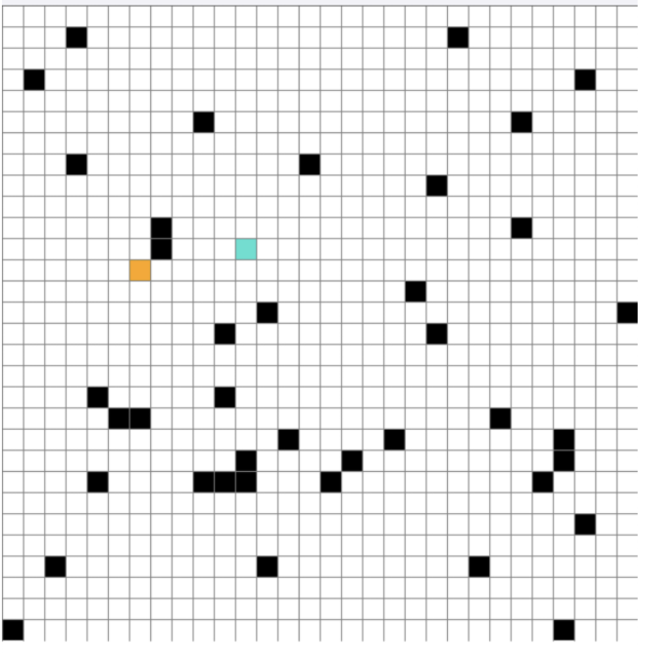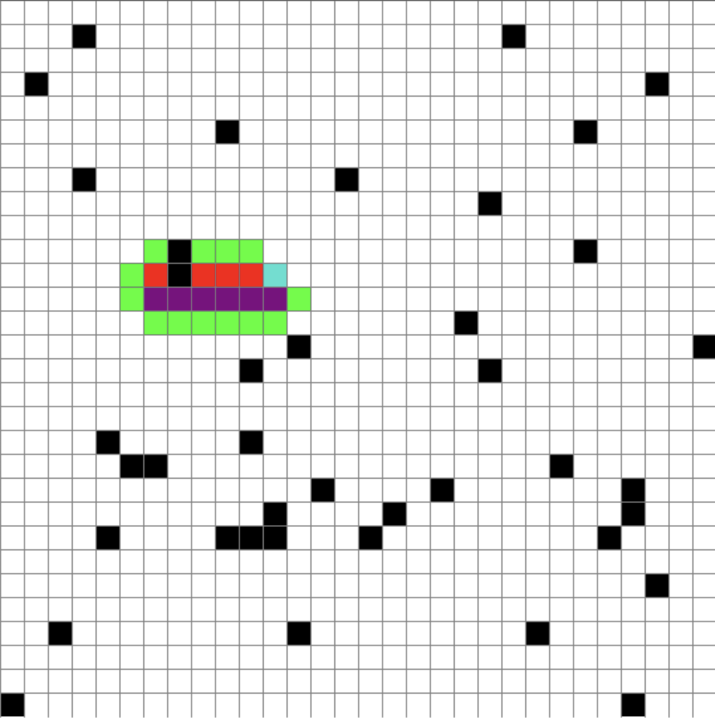

Useful Project Links
Project Github repository link here: VioletBenin/DesingingIntelligentAgentCW (github.com)

